Exp.No-19
19. Perform Edge detection using Sobel Matrix along XY axis

Aim:
To detect the edges of an image along both X and Y directions using the Sobel operator.
Procedure:
- Start the program.
- Import the required libraries.
- Read the input image (puppy.jpg).
- Convert it into grayscale.
- Apply Sobel X and Sobel Y.
- Combine both edge images.
- Display the original and combined edge images.
- Save the output image.
- Stop the program.
Program:
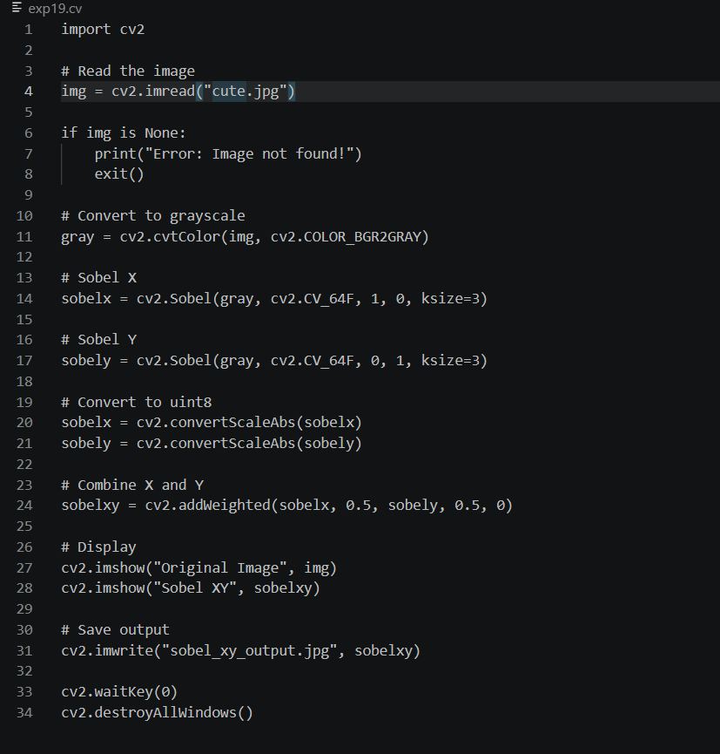

Input:

Output:
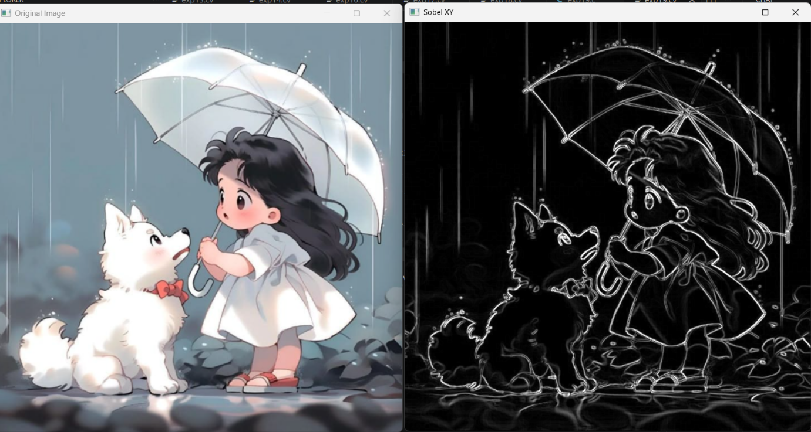
Result:
The edges along both X and Y directions were successfully detected using the Sobel operator.

